  



**Virtual Internship in association with EduSkills**

**Palo Alto Networks Academy 2022**

# BEACON

**Enrollment Guide**

## Introduction

* This guide covers how to sign up for BEACON and how to access study resources and courses for the **Palo Alto Networks Cybersecurity Entry-Level Technician (PCCET)** certification.
  + **BEACON** is a self-paced learning portal collection of resources for certification and more.
  + The **PCCET** demonstrates a candidate’s understanding of industry recognized topics in networking and cybersecurity

fundamentals, in alignment with NICE/NIST standards.

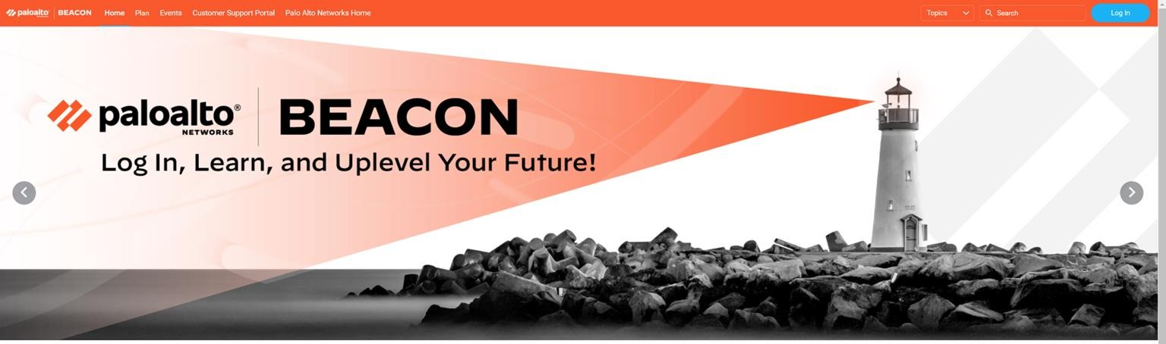

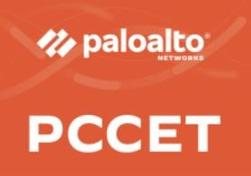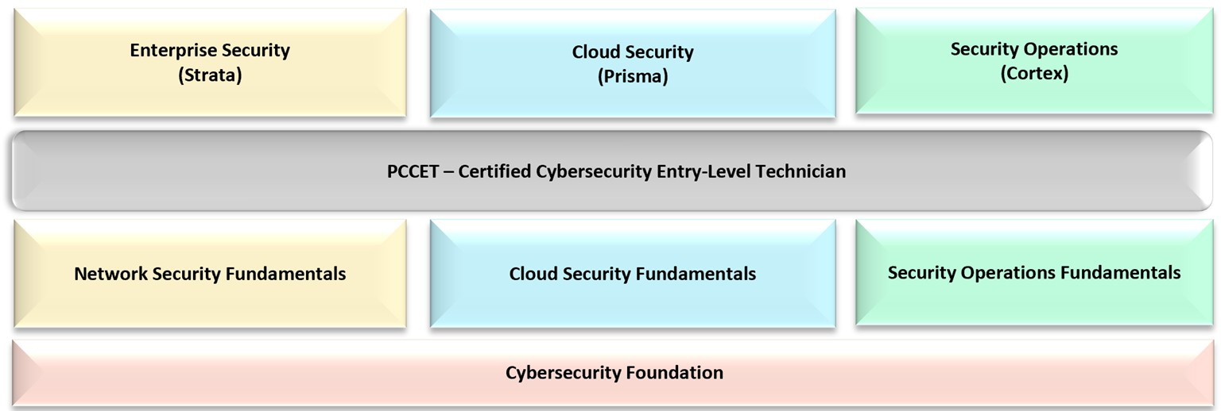

**Curriculum Roadmap**

##### STUDY GUIDE COURSEWARE CERTIFICATION

**Palo Alto Networks Certified Cybersecurity Entry-level Technician (PCCET)**

**Cybersecurity Survival Guide**

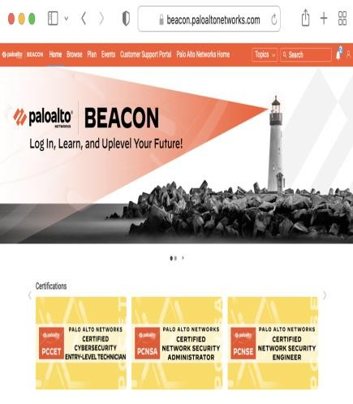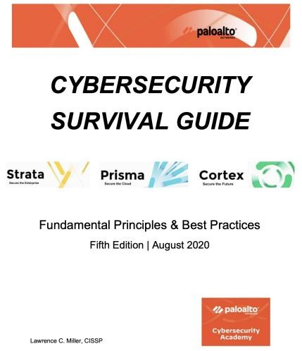

This book provides a valuable overview of today’s threat landscape and describes the tools and technology required to defend against today’s cyber attacks.

**BEACON**

* eLearning Courses
  + Introduction to Cybersecurity
  + Fundamentals of Network Security
  + Fundamentals of Cloud Security
  + Fundamentals of SOC

**Exam Preparation Material**

* Exam Datasheet
* Exam Blueprint
* PCCET STUDY GUIDE
* Practice Exam

## BEACON- Account Creation

* Create a Palo Alto Networks Beacon account to access the PCCET Digital Learning courses.
  + Open a browser and navigate to: <https://login.paloaltonetworks.com/lms/PreRegister?UserType=CUST&source=Beacon>
  + Enter your college **email address that is registered with AICTE internship.**
  + Enter the **captcha** mentioned.
  + 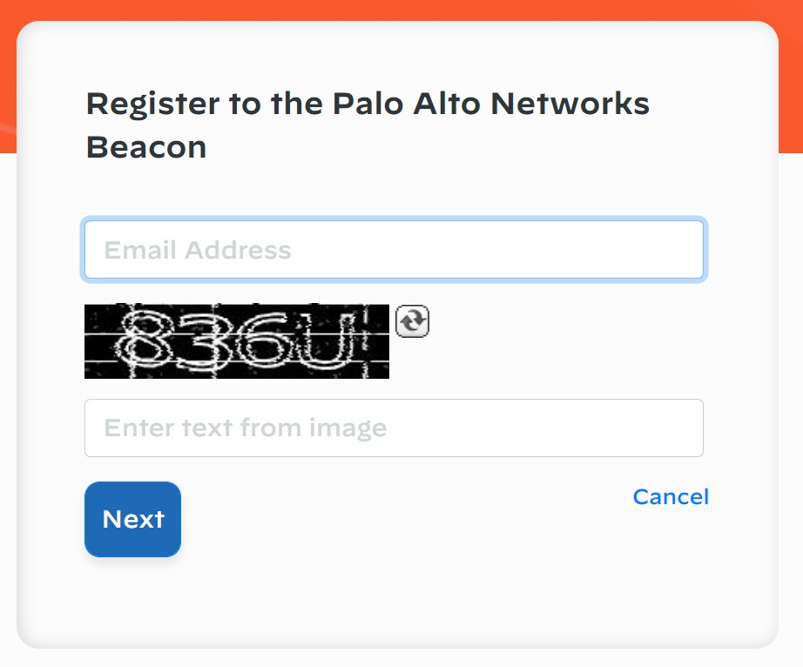Click on **Next**.

#### Please **enter** your details on the screen shown.

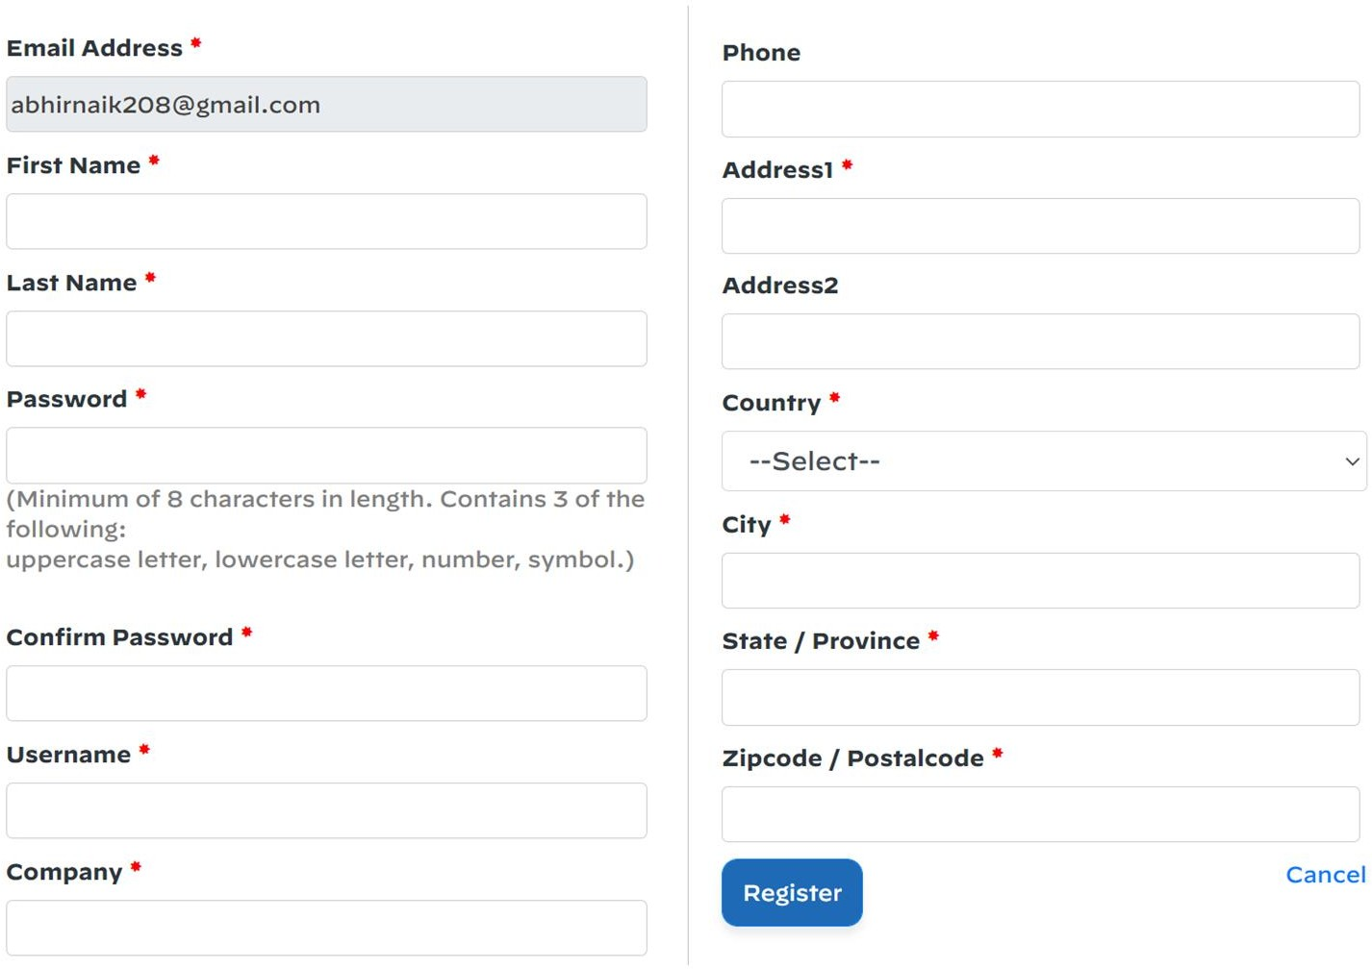

* Please **enter** your **‘Institution name’** under the company field.

#### Do not forget the password that you’ve entered.

* Click **Register**.

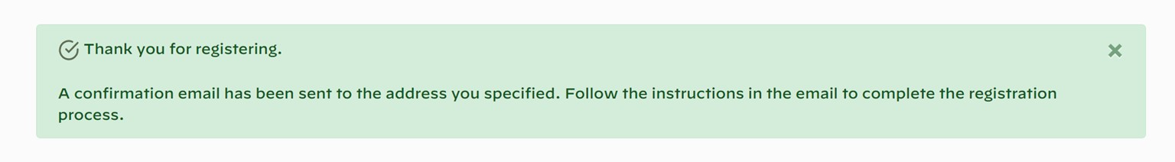

Please check your email.

* + **Click** the link in the email to activate your account.
  + Login using the **email** and **password** you used to create the account.
  + Create unique security **questions** and answers to help secure your account.

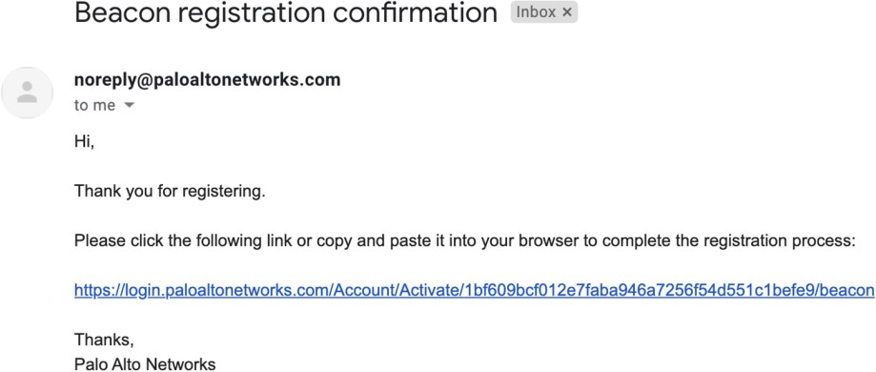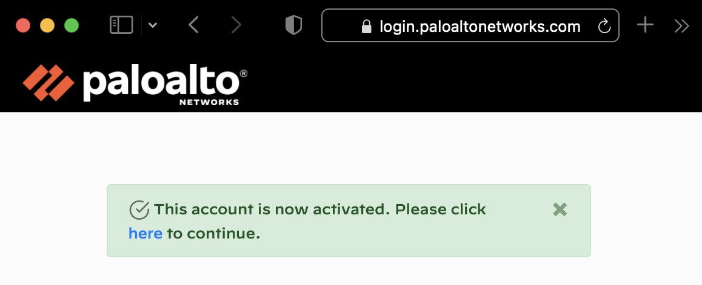

## How to Log in

* Please navigate to <https://beacon.paloaltonetworks.com/>
* To login please click on the login button on the top right corner.

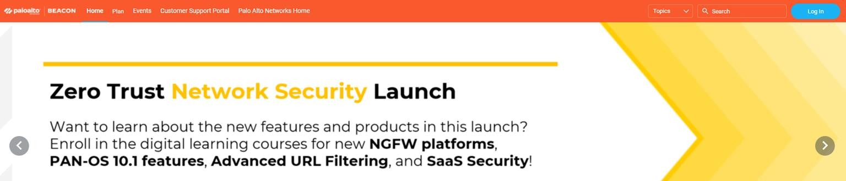

### Once you land on the login page as shown in the image, please enter your

**full email address** and then click on **NEXT** and enter your **password.**

* Please Log in using your **laptop** and not through **phone.**

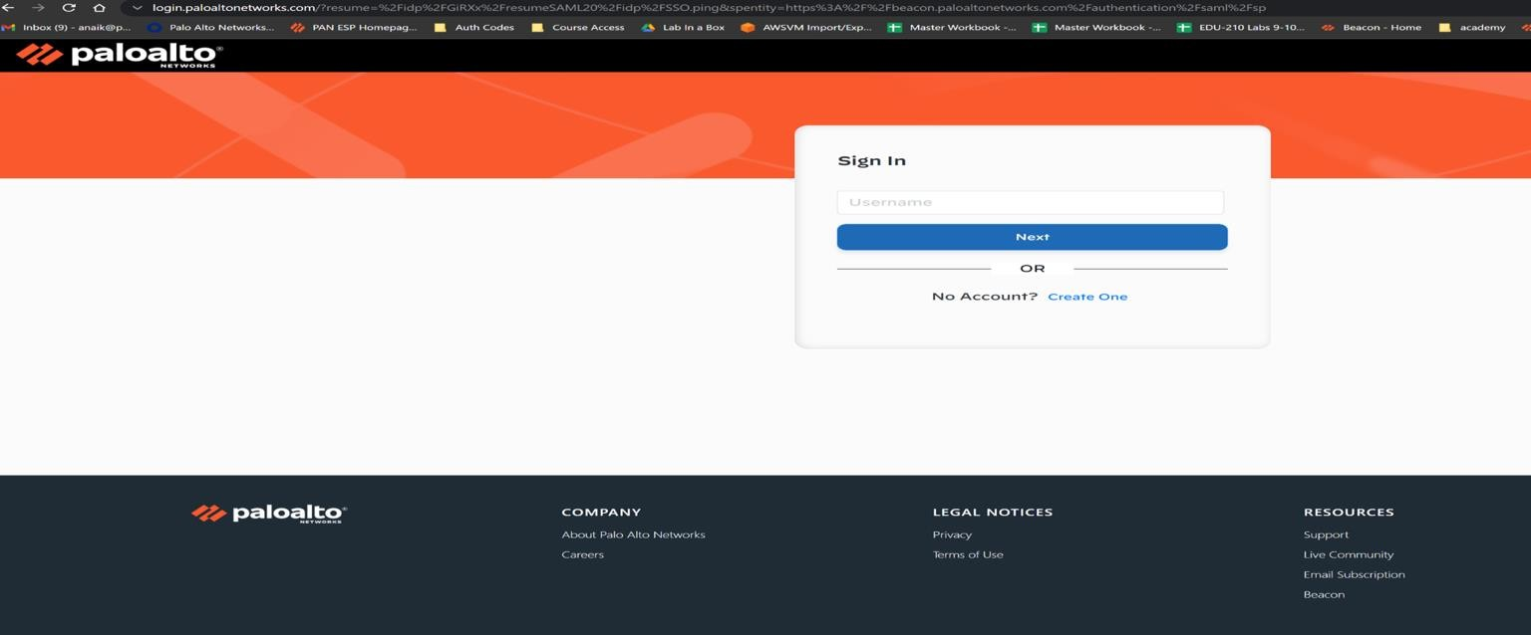

## Update Timezone

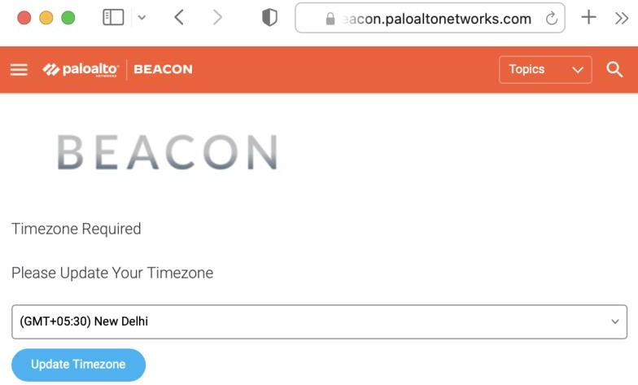Please update your timezone relative to your country

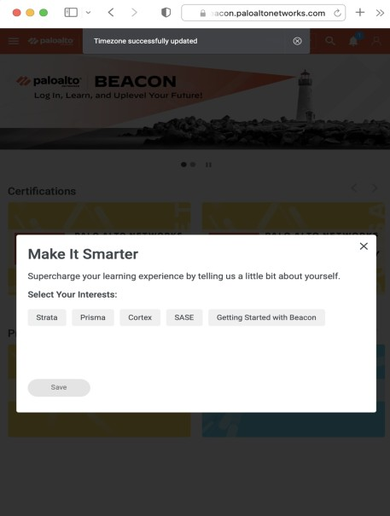

* + Once done, **click** on the cross**.**

### Once you enter your correct credentials and update the timezone you’ll then be directed to the main BEACON Page

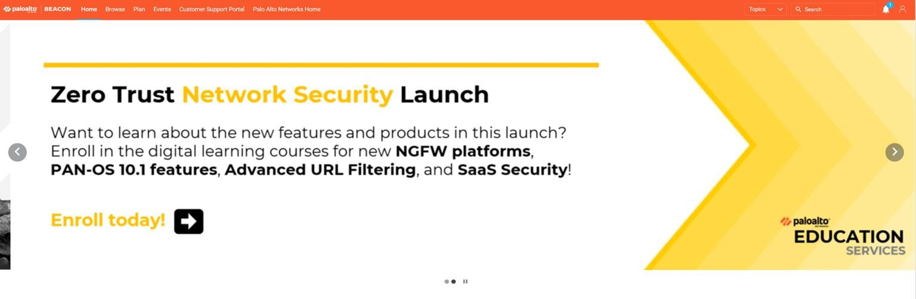

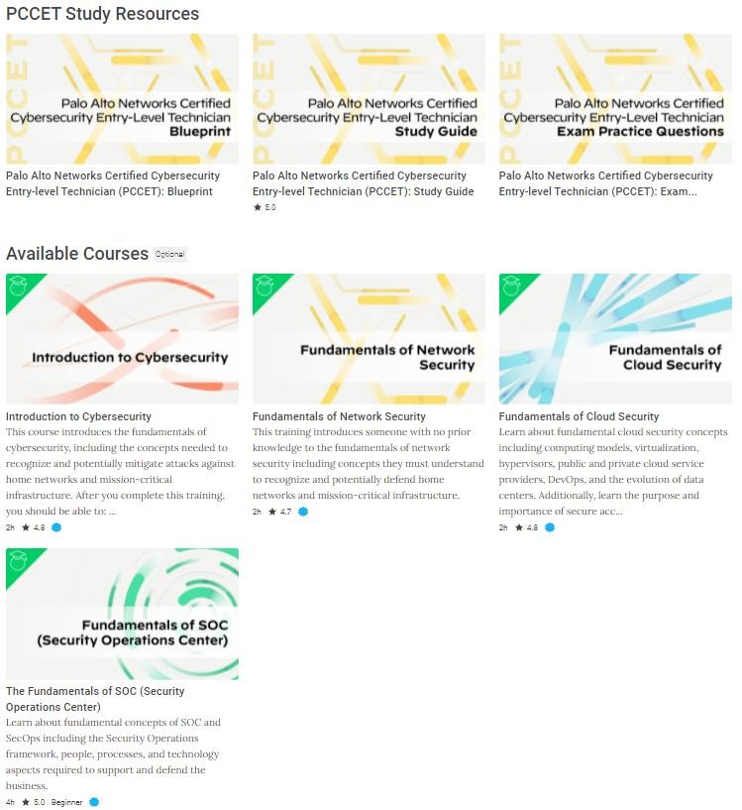

###### To enrol yourself in the PCCET course click [here](https://beacon.paloaltonetworks.com/sl/3c5535f5).

Or type:

* + - [https://beacon.paloaltonetworks.com/sl/3c5535](https://beacon.paloaltonetworks.com/sl/3c5535f5)

[f5](https://beacon.paloaltonetworks.com/sl/3c5535f5)

###### You will now land on a page as shown in the image

* The following courses and study materials are required in order to better prepare for the PCCET Certification

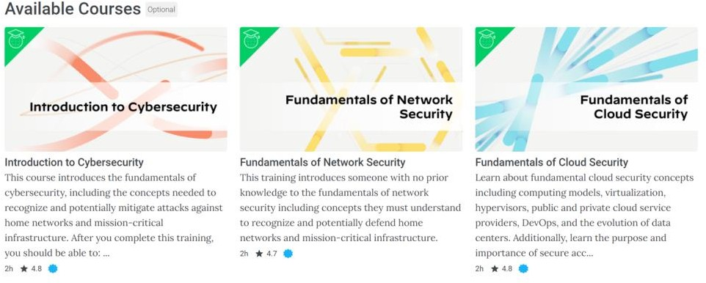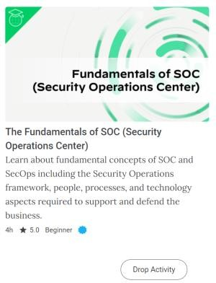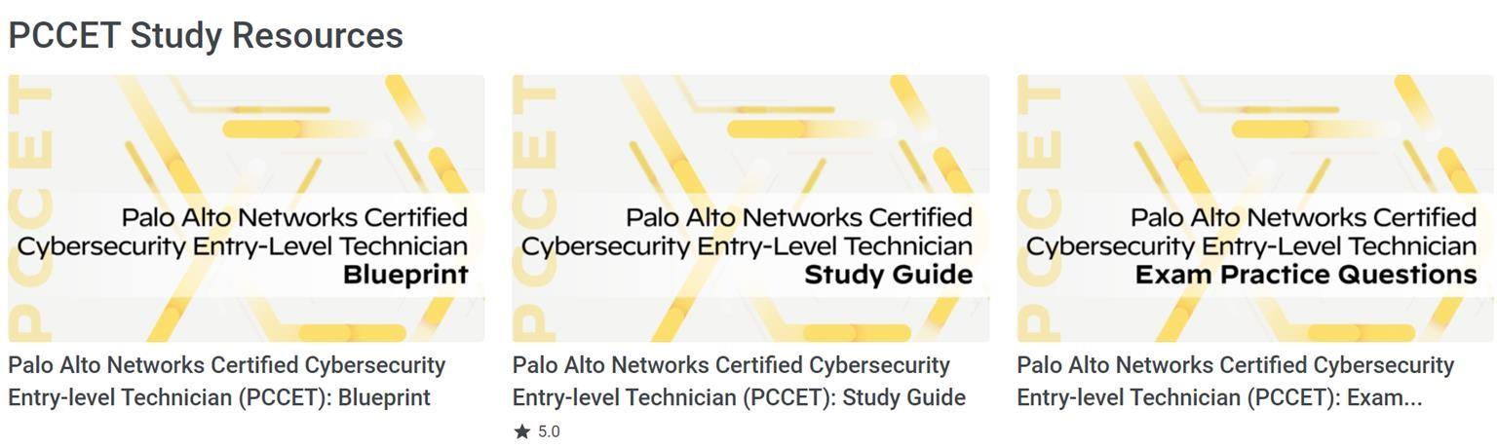

* Click on the first course that is **Introduction to**

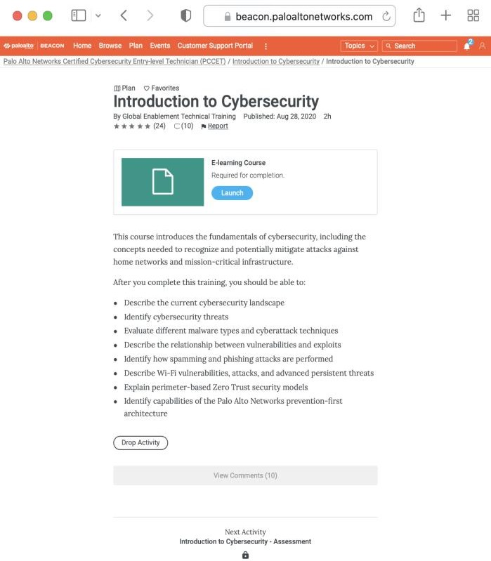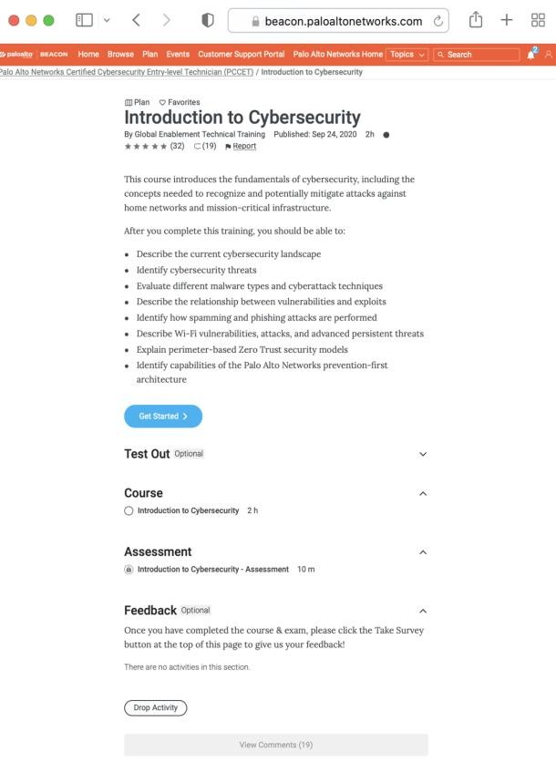

**Cybersecurity.**

* Click on the **Introduction to Cybersecurity** button which will then take you to the E-Learning page
* Click on the **Launch** button to access the eLearning material.

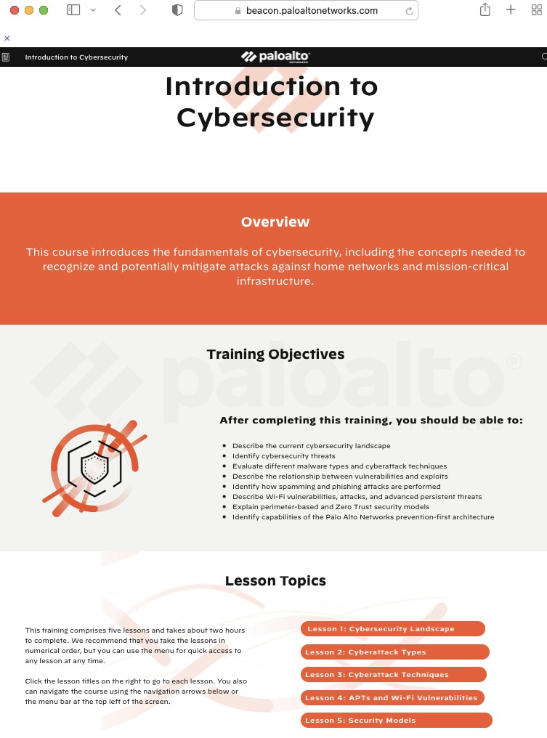

* + You will then see the **reading material** for the

course, as shown in the image.

* To check the history and completion of your specific course.

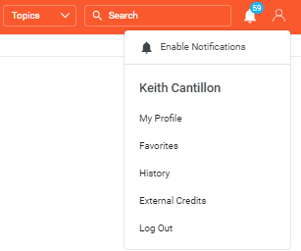

* + Please navigate to your profile on the top right of the screen and choose history.
  + To check your completion certificate please go to the My Profile page. See example below:

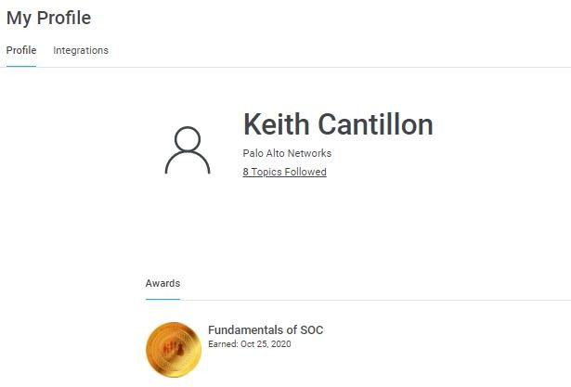

### Complete all four courses on the PCCET learning Track

* Study the Blueprint carefully

### Deep dive into the Study guide & Cybersecurity Survival Guide

* Take Practice Exam Questions

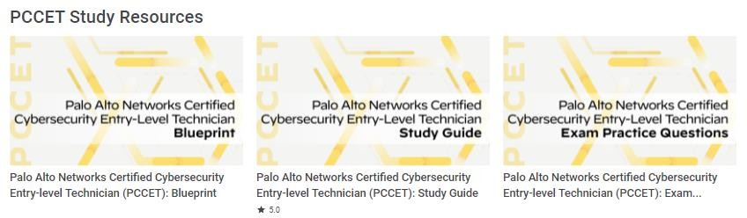

### Other course recommendations but not required - PCNSA course.

* 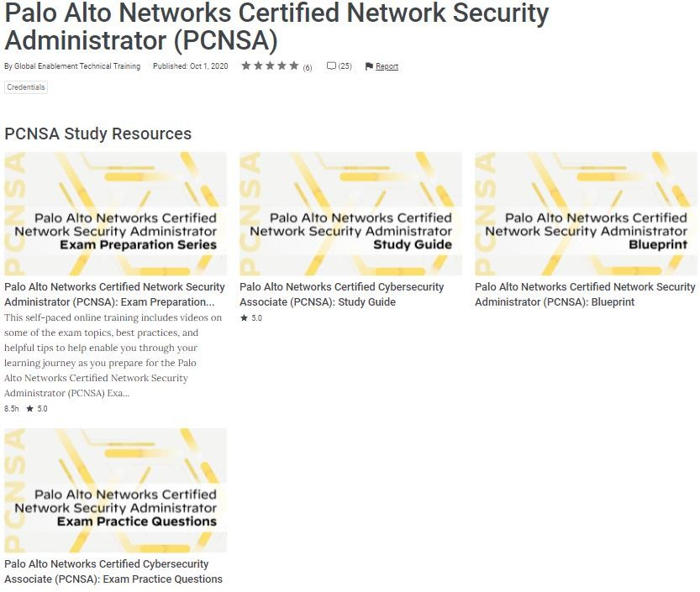Search for PCNSA using the search toolbar





[**www.paloaltonetworks.com**](http://www.paloaltonetworks.com/)

| © 2021 Palo Alto Networks, Inc. All rights reserved. Confidential and proprietary.

DO NOT SHARE outside of WW Professional Services and Customer Support organization

# Thank you